
PERFORMING ARTS APPLICATION

Deadline for submission of application:

Friday, September 30, 2016
Name
Street Address
City, ST Zip
Home Phone Best Time of Day to Call
E-Mail address (required)

Are you a Student or Staff? School: Grade:

Are you an Individual (Soloist) or Performing in a Group? # in Group:

If in a group, please provide the names of all persons in your group.

Group Name:

REMINDER: An application form must be completed for each group member.
Group applications must be submitted together. (Required)

Talent (song, dance, instrumental, etc.): _____________________________________

INFORMATION FOR YOUR INTRODUCTION (limit to 100 words-brief description of talent and your performance experience):

Additional Equipment requirements:
Piano, microphones (standing), chairs, sound system, music stands and a CD player will already be provided.
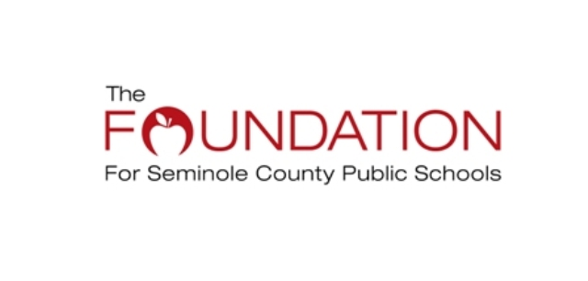

Photograph, Motion Picture, & Video Consent:

Waiver and Release Form

For and in consideration of benefits to be derived from the furtherance of the educational programs of the Seminole County Public Schools, Florida, (I), (We), the undersigned parent(s) or legal guardian(s) of _____________________________________________, a student entered in the Seminole County Public School system, do hereby consent, authorize, and grant permission to the Seminole County Public Schools, Florida, its agents, employees, or duly authorized representatives to take photographs, motion pictures, or video tapes of said student, and do further consent to the publication, circulation, and dissemination of said photographs, motion pictures, or video tapes, or any duplication or facsimile thereof for any purpose it may deem proper.

In granting such permission, (I), (We) hereby relinquish and give to the Seminole County Public Schools, Florida, all right, title, and interest (I), (We) may have in the finished pictures, negatives, reproductions, or copies, and further waive any and all right to approve the use of such photographs, motion pictures, or video tapes and further do waive any right to compensation for the publication or other use of said photographs, motion pictures, or video tapes and do release Seminole County Public Schools, Florida, its agents, licensees, representatives, and assigns from any and all claims of any nature whatsoever from their use.

___________________________ _________________________________
School Parent or Guardian Signature

___________________________ _________________________________
Date Home Street Address

_________________________________
City, State, and Zip Code

The Foundation for Seminole County Public Schools invites all talented students and staff from Seminole County Public Schools to schedule an audition for the

20th Annual Arts Alive in Seminole!
Saturday, November 12, 2016
The Westin Lake Mary

Deadline for submission of application:
Friday, September 30, 2016
All performers must be enrolled or employed by Seminole County Public Schools. Family members may perform along with a student or employee.

Auditions will be held Monday, October 10 at Winter Springs High School and Tuesday, October 11 at Seminole High School.

Seminole High School is located at 2701 Ridgewood Avenue in Sanford. Winter Springs High School is located at 130 Tuskawilla Road in Winter Springs.

- Auditions times will be scheduled in 30-minute windows starting from 3:00 p.m. - 8:00 p.m. Plan to arrive at least 30 minutes prior to your scheduled audition time block. When you arrive, check in with The Foundation staff in the auditorium lobby and you will be issued an audition number.

Dance and Vocal Performers: If you require recorded music to perform your talent, you must bring a CD for the audition and leave it with The Foundation staff member at registration. IT WILL NOT BE RETURNED. The CD must be compatible with standard audio equipment. No tapes.

Background music can be purchased at websites such as www.musicminusone.com and www.pocketsongs.com.

If you plan on using live accompaniment the night of the event, you must audition in that manner.

  - If performing as a group - an application form must be completed for each group member. Group applications must be submitted together.

All performances are to be a MAXIMUM of THREE minutes in length. You will be asked to stop if you go over the time limit.

Piano, microphones (standing), chairs, sound system, music stands and a CD player will be provided. Performers must provide all other equipment! You must audition with the equipment that will be used at the November 12th performance.

Restrooms at Seminole High School and Winter Springs High School are available for changing.

No cameras, videos or recording devices will be allowed. Parents will be permitted to sit in the rear of the auditorium during their child’s audition.

You will be notified via e-mail no later than October 5, 2016 of your scheduled audition time. We cannot guarantee a particular day or time for auditions. Please call 407-320-0196 if you have any questions or are unable to attend your scheduled audition time. Note: As all audition times have been assigned, please try and make your scheduled time. We cannot guarantee another date and time.

A Photograph, Motion Picture and Video Consent Form must be signed by each performer and parent/guardian and returned with a completed application.

Those who are chosen will perform in the ballroom at The Westin Lake Mary on Saturday, November 12th and must be available for the afternoon/evening dress rehearsal on Friday, November 11th.

Note: A limited number of acts will be selected by the audition judges for the November 12th performance.

Send application through mail, courier, fax or e-mail to:

Arts Alive in Seminole!
The Foundation for Seminole County Public Schools, Inc.

400 E. Lake Mary Blvd, Sanford, FL 32773-7127
Phone: 407-320-0196 * Fax: 407-320-0285
E-mail: Foundation@scps.us

